# How to set up the 717 Synthesis Report Generation Tool on your computer

## 1. Download R

* You can download R from their official website: <https://www.r-project.org/>
* Click on “download R” on the main page.

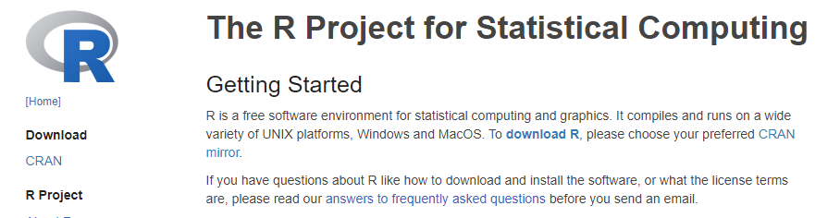

* Choose any CRAN mirror (doesn’t really matter what you choose), and download the R suitable for your OS (Windows or Mac)

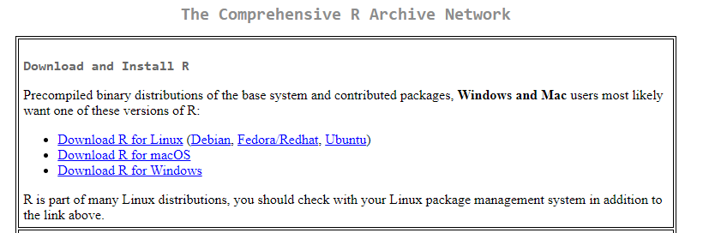

* Open the downloaded file and follow the instructions to complete installation.

## 2. Download R studio

* Go to this website: <https://posit.co/download/rstudio-desktop/>
* If your computer OS is Windows, click on “Download RStudio Desktop for Windows” button to download the installation file.

* If your computer OS is not Windows, scroll down to the table and choose the correct installation file.

* Run the installation file (exe) to complete the installation.

## 3. Install the required packages

* Download the zip file (717 autoreport.zip) for the tool and extract it on your local directory.
* Open the folder, and double-click on  to open the Rproject. This should open the Rstudio.
* On the bottom-right pane, go to the “Files” tab. Click on the “scripts” folder and open “0_INSTALL PACKAGES.R”. This will open the script on the upper left pane.

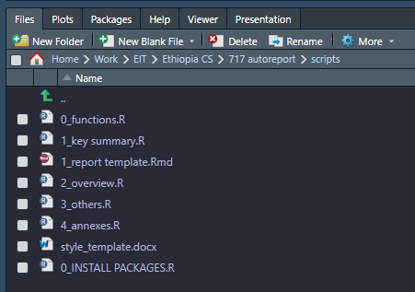

* Run each line of the script one by one by putting the cursor on each line and running Ctrl + Enter. This will trigger installations of all the packages required for this tool. Each line may take some time. When the line is still running, the **“>”** sign at the console panel (bottom-left) will disappear. When the run is complete, **“>”** sign will appear again.

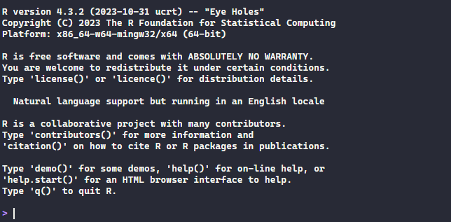

* Once all the lines are run, close this script.

**Now you’re all set to go!**